



**Software process Management**

**Group Assignment**

**UGC/MIS/18.1**

S

Hospital Management System

FINAL REPORT

**CONTENT**

**1.Abstract…………………………….……………………………………………2**

**2.Introduction……………………………………………………………………..2**

**3.System Requirements…………………………………………………………..4**

**3.1-Hardware Requirements………………………………………………4**

**3.2- Software Requirement …….………………………………………….4**

**3.3-Functional Requirements……………………………………………...4**

**3.4-Non-Functional Requirements……………………………….………..5**

**3.5-Feasibility study……………………………………………….………..5**

**4.Design Approach…………………………….…………………………….……6**

**4.1-Introduction to Design………………………………………………….6**

**4.2-UML diagram……………………………….…………………………..6**

**5.Agile Methodologies…………………………………………………………….7**

**5.1-Agile Concept………………………………………………………....….7**

**5.2-Time Estimation……………………………………………………...….7**

**5.3-Cost Estimation……………………………………………………...…..8**

**6.System Development……………………………………………………………9**

**6.1-Design Specification……………………………………………………..9**

**6.2-Output screens……………………………………………………..…...10**

**7.Implementation…………………………….. .…………………………….......16**

**7.1-Concepts and techniques………………………………...………….....16**

**7.2-Testing……………………………………………………………..........16**

**08.Contribution…………………………………………………………………...17**

**09.Conclusion………………………………………………..……………………38**

**10.Future Enhancement………………………………………………………….38**

**11.References……………………………………………..……………………….39**

**1.Abstract**

Most hospitals currently use a manual system for the management and maintenance of critical information. The current systems require numerous paper forms, with data stores spreads throughout the hospital management infrastructure. Often information is incomplete or does not follow management standard.

A significant part of the operation of any hospital involves that acquisition, management and timely retrieval of great volume of information. This information typically involves;

Hospital staff’s personal information and medical history, ward scheduling, staff scheduling, clinical services, doctor channelling, test results, treatments and various types of other facilities are provided through this system. All of this information must be managed in an efficient and cost-effective way.

So, if the resources may be effectively utilized HMS will automate the management of the hospital making it more efficient and error free.

**2. Introduction**

Hospital Management system is a computerized system designed and programmed to deal with day to day operations taking place. The program can look after inpatients, outpatients, records, database treatments, making appointments, status illness, billing in the pharmacy and labs, clinical services etc. It also maintains hospital information such as ward id, doctors in charge and department administrating. The purpose of this project is to computerize the front office Management of Hospital to develop software which is user friendly, simple and cost-effective. It deals with the collection of patient’s information, diagnosis details etc.

The proposed software product is the Hospital Management System (HMS).The System will be used to get the information from the patients and then storing that data to get the information from the patients and storing that data for future usages. The Current System is a paper-base System. It is too slow and cannot provide updated lists of patients within a reasonable time frame. The intentions of the system are to reduce over-time pay and increase the number of patients that can treated accurately. Requirements statements in this document are both functional and non-functional.

**Project Description**

Hospital Management System is powerful, flexible, easy to use and is designed and developed to deliver real conceivable benefits to hospitals and clinics and more importantly it is backed by reliable and dependable. This system is designed to multi-specialty hospitals, to cover a wide range of hospital administration and management processes. It is an integrated end-to-end Hospital Management System that provides relevant information across the hospital to support effective decision making for patient care, hospital administration and critical financial accounting.

The software is for the automation of Hospital Management.

It maintains two levels of users: -

* Administrative level
* User Level

The Software includes: -

* Maintaining Patient details.
* Maintaining Staff details.
* Channelling Services
* Providing and maintain all kinds of tests for a patient.
* Give Treatment advices
* Description of medicines and their prices.

**Maintenance**

The maintenance phase focuses on change that is associated with error correction, adaptations required as the software’s environment evolves. Changes are encountered during the maintenance phase are

* Correction
* Adaptation
* Enhancement
* Prevention

**3. System Requirements**

**3.1-Hardware Requirements**

* Operating System- Windows
* Hard Disk- 1TB
* RAM- 8GB
* Processor – i5

**3.2-Software Requirements**

* Angular Version 9
* CSS
* Bootstraps
* IDE-Visual Studio Code
* MS SQL Server

**User interfaces**

* Input from the user will be via keyboard and mouse point and click.
* The user will navigate through the software by clicking on icons and links. The icons will give appropriate responses to the given input.

**Communication protocols and Interfaces**-

This project can compatible with all platforms. Project supports all types of web browsers.

**3.3-Functional Requirements**

The hospital management system organizes the stable functioning of daily tasks and interactions. This is a special tool to support the smooth operating of the software components that are vital for the clinic administration. They can receive the test results or medical reports by email or the user account. Any clinic should store medical histories, test results, prescribed treatments, etc. Hospital s administrative functions, reporting requirements, historical data are functional requirements include in this project.

**3.4-Non-Functional Requirements**

Therefore, any of these functions are designed to make the clinic management system

* Easy to use,
* comprehensive,
* Secure
* Powerful and
* Reliability
* Recoverability
* Maintainability
* Usability

**3.5-Feasibility study**

Once the problem is clearly identified feasibility study is conducted. It is a high level version of entire system analysis and design process. The main objective is to determine how to solve a problem with a minimum expense.

Feasibility study comes under main points as

* Economical Feasibility
* Technical Feasibility
* Operational feasibility

**Economical Feasibility**

We have developed the system under the hospitals point of view. So it is cost effective as it has eliminated the paper work. Used of this system is highly accurate and contains minimum errors. And also this has gain more profits to the organization. And helps to utilize the manpower.

**Technical Feasibility**

The system was developed in Angular. This provides the high level of reliability, availability and compatibility. This was helps to evaluate the hardware, software and other technical requirements of the system.

**Operational Feasibility**

The system is very easy to use and understand to anyone as it is very simple with attractive interface.

**4.Design Approach**

**4.1-Introduction to Design**

Design is the first step in the development phase for any techniques and principles for the purpose of defining a device, process or a system. After we analysed and specified the software requirements design phase involved in technical activities such as design, coding, implementation and testing. This helps to build and verify the software system.

To deliver a successful quality product design is most important with the required data.

**4.2-UML Diagram**

**Use Case Diagram**

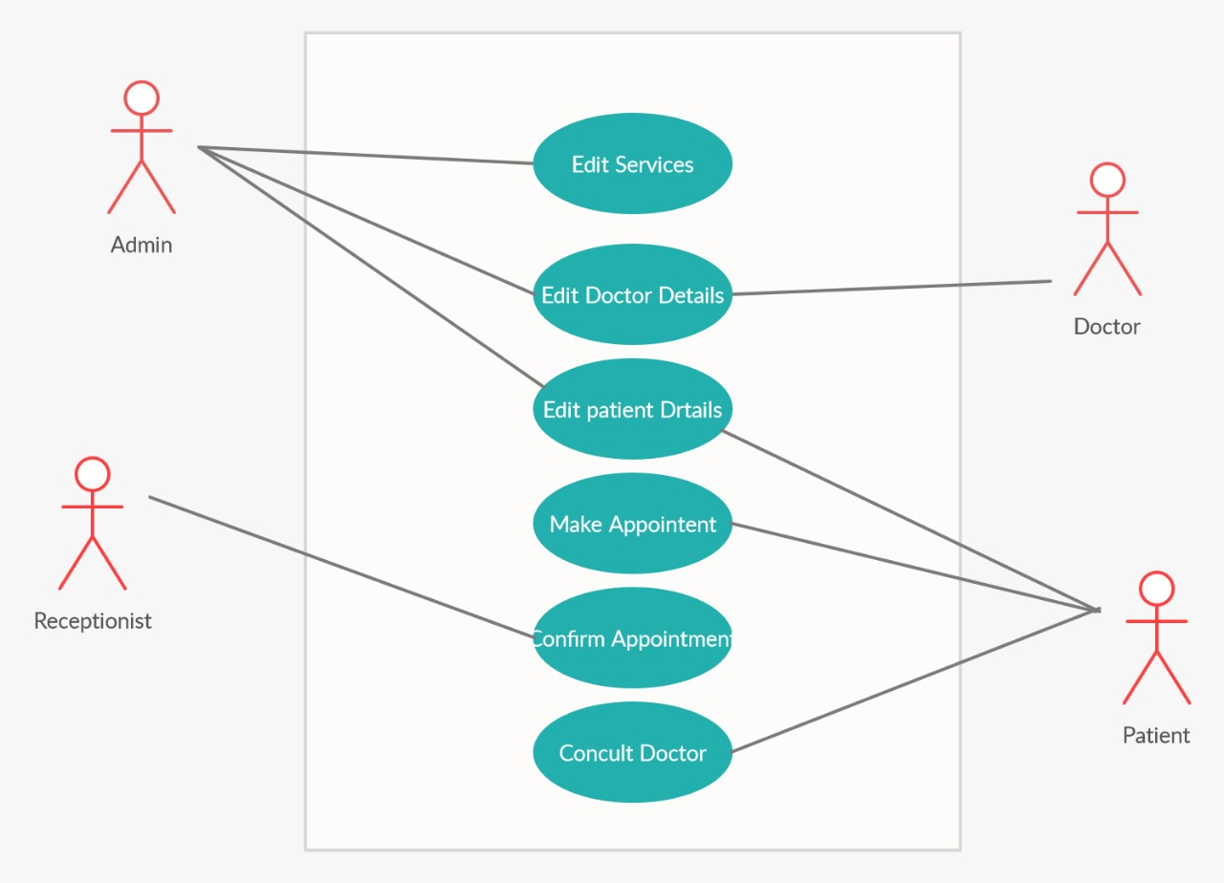

Here the purpose is to show the interactions between the use case and actors.

**5.Agile Methodologies**

**5.1-Agile Concept**

Agile processes offer flexibility and helps team produce short, working products in shorter sprints. In our project we use agile scrum methodology. It is a spring based system and was easy to deliver a product with the highest value. Scrum is a framework which allows for more effective collaboration among our team members. Each sprints goal is to built the most important features and deliver the high quality product. This encourages to built the product very fast as all the set of goals are identified clearly and planned within the given time frame.

As the Agile scrum methodology is very flexible it is very easy to handle. If there are any problem arise or have to do any changes scrum team can easily identified and adjust to the product goal very quickly. Here all the members in the team have assigned to a task and we have kept all the team members updated on their tasks to do through weekly stand up meetings.

**5.2-Time Estimation**



**5.3-Cost estimation**

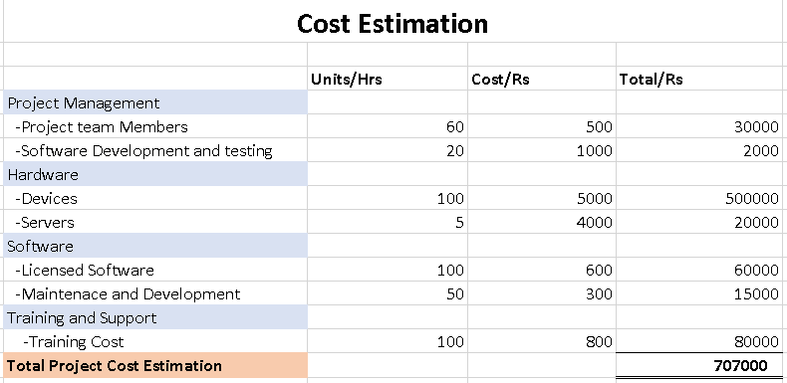

Assumptions-Assume that this is a moderate class=2

So sum of all Fi is 14 *2 =28

Functional Point =count-total * CAF

= count- total *[0.65 + 0.01 * ∑ (Fi) ]

= 707000 * [ 0.65 + 0.28 ]

= 657,510

6.**System Development**

6.1-Design Specification

Hospital Management website page should be shown concise so that it should be comfortable for the users administrators and developers, and the responsive web design was used to fulfill the requirement which can be well suited to different type devices with flexible screen, such as the PC and mobile phones. Hospitals must be mindful of the fact that a large majority of those visiting their website are experiencing an emergency, or will need to find information very quickly prior to a visit. So, This web application be very easy to navigate quickly. Most commonly accessed information and appointment making area is present in home page and design also planned to make fully accessible on mobile devices. Navigation bar at the top of the homepage. Clear organization will keep visitors engaged with this site content and encourage them to spend more time on this web application. some useful links are added to the home page. Logo is very simple and clear. Services section has large buttons so user can easily click it. Appointment section is in middle of the home page it design as very user friendly. In information page there is a staff.

The developed system provides a user-friendly graphical interface and features. User can see doctor’s information on white background. Information can read easily. In medicine section user can see some medicine with small description. On the footer section social media icons some related links are placed. Login and user registration pages are very simple. Hospital management web application should be features are concentrated on providing the smooth experience of patients. Users expectations are different but many of them are covered. Quality and security is important in medical industry. This design improves the efficiency of medical services for patients. The interactions between the hospital and the patient be simplified by design. Present the most commonly accessed information and files from a central location. The system requires very low system resources, and the system will work in all configurations. It has minimum manual data entry. Site navigation is clear, concise, and easily understood.

**6.2-Output screens**

**Login Page**

The login form is to give access to the system. By entering the username and a password user can get registered to the system.

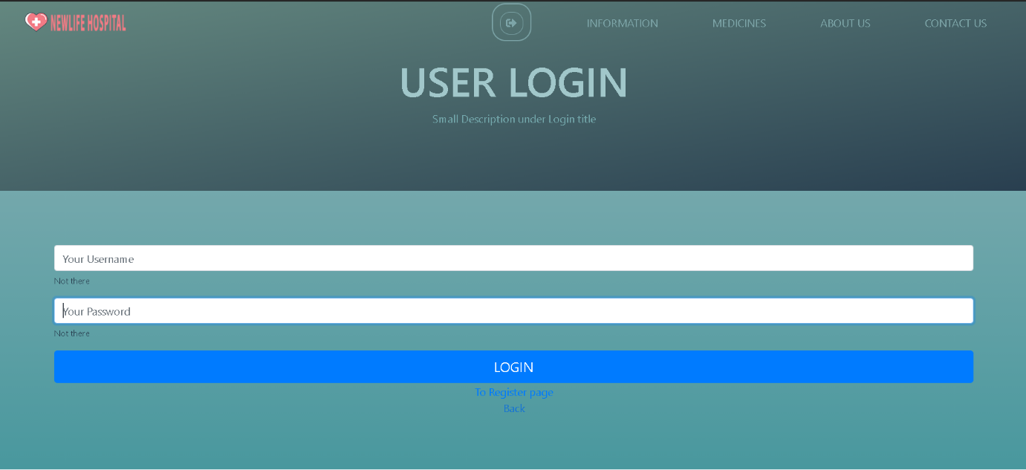

**Home Page**

This is the main page a person can see when accessing to the system. Here the page have displayed the main functions they are doing. First the system have shown the user what are the services they are delivering and next the system have displayed how to make an appointment to channel your doctor. And also system have generated a contact form for the users.As the system is user friendly and simple it is very easy to use.

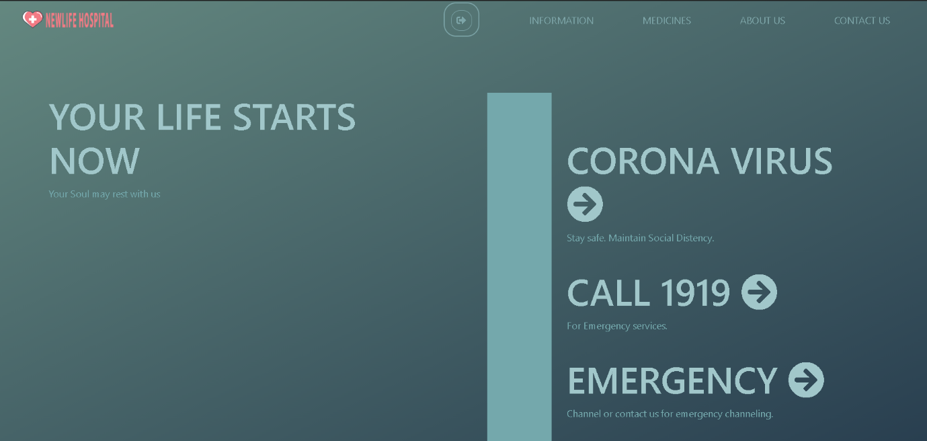

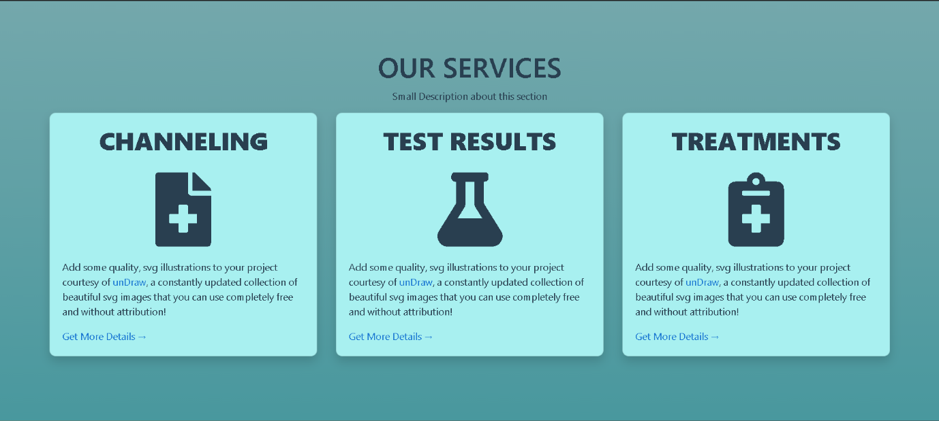

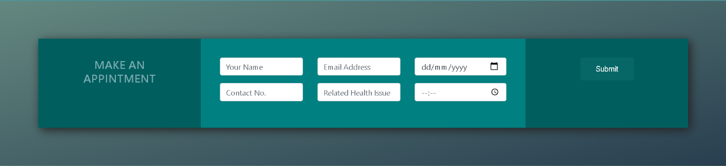

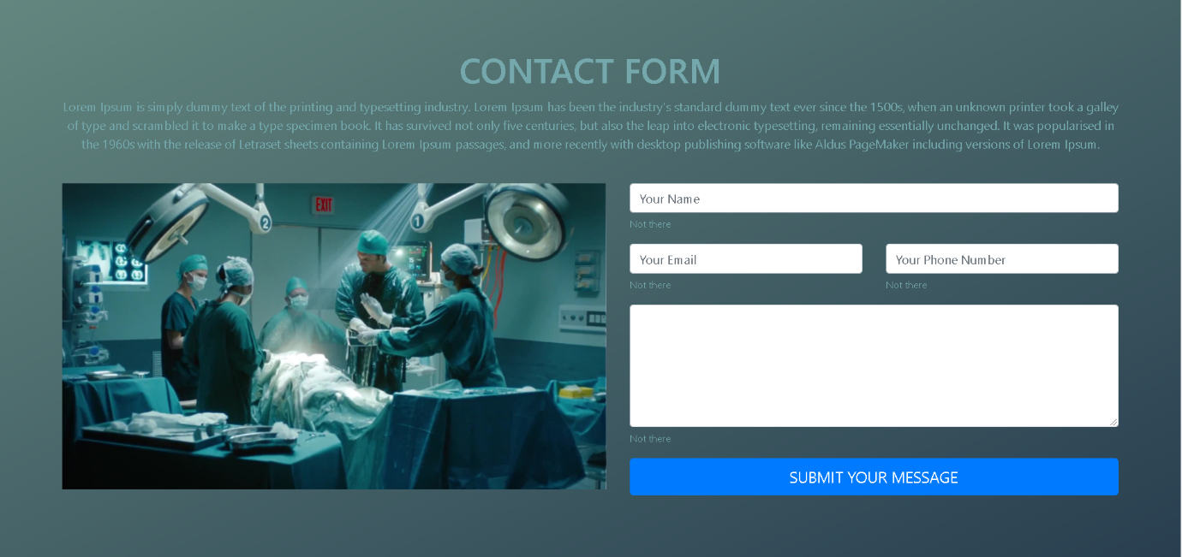

**Information Page**

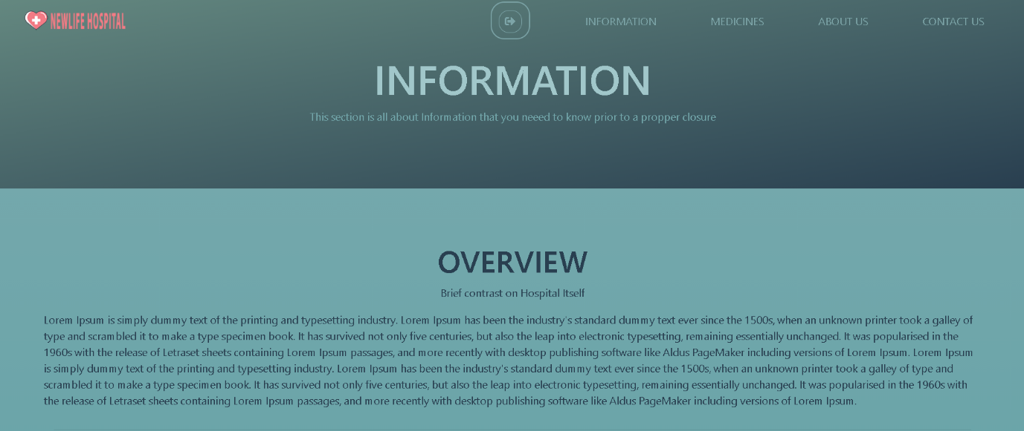

**Hospital Staff Page**

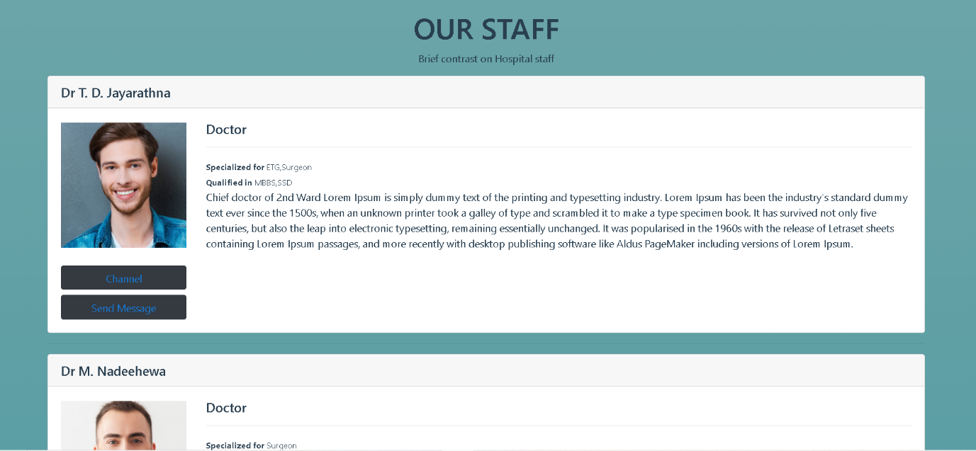

**Medicine Displayer Page**

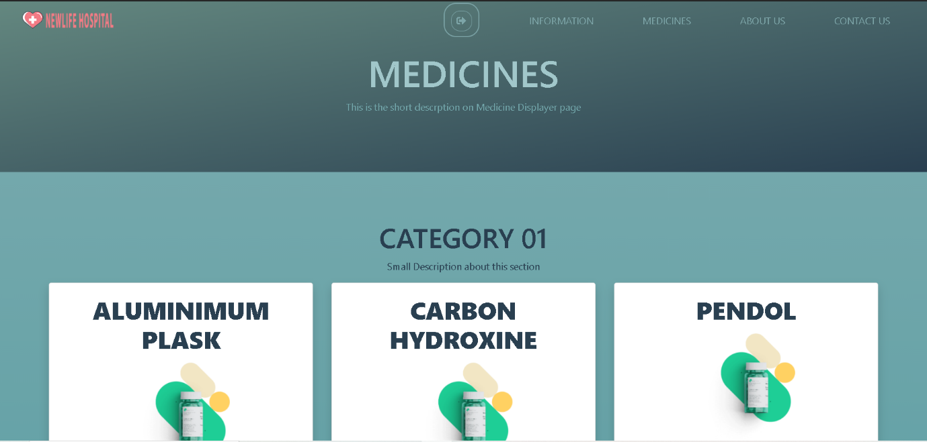

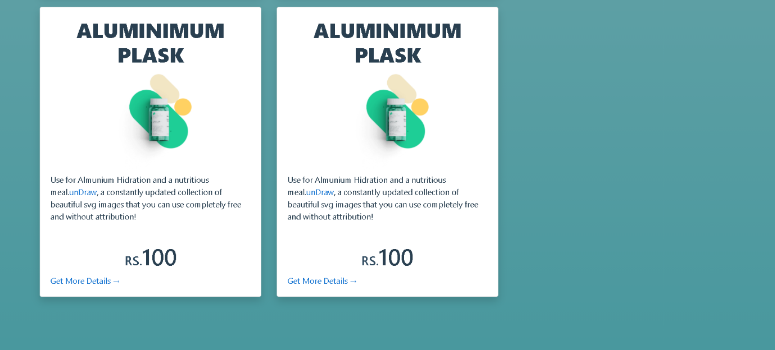

**About Us Page**

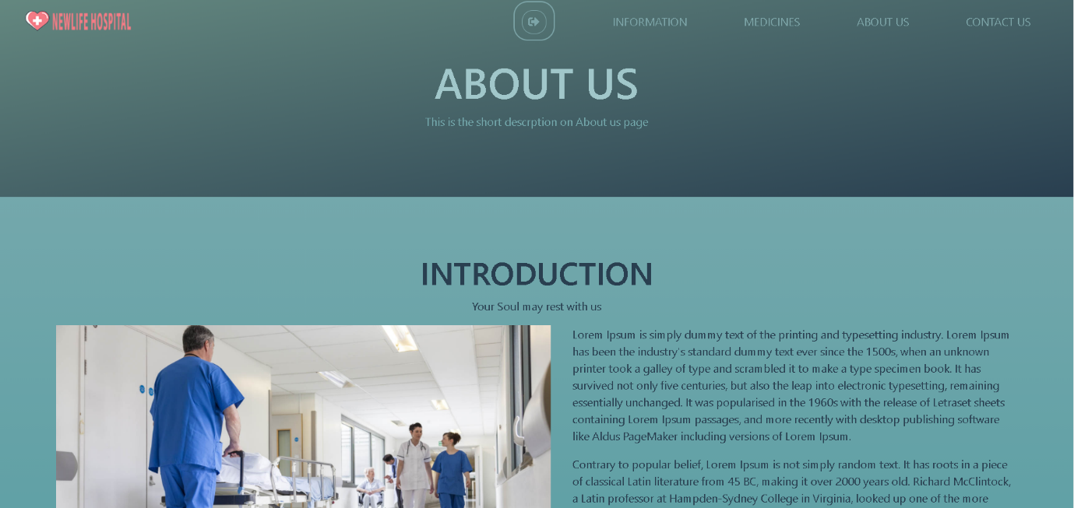

**Contact Us Page**

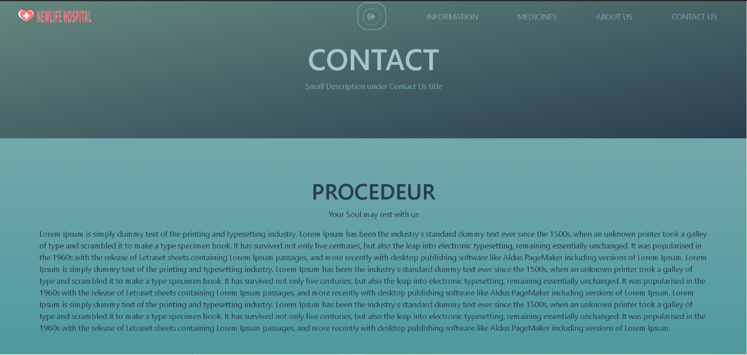

**Database Design**

We used cloud firebase to store our data. It has a similar set as a real-time database.

It is very easy to use and can find out any time when the record is added. Cloud firebase is highly scalable and managed.

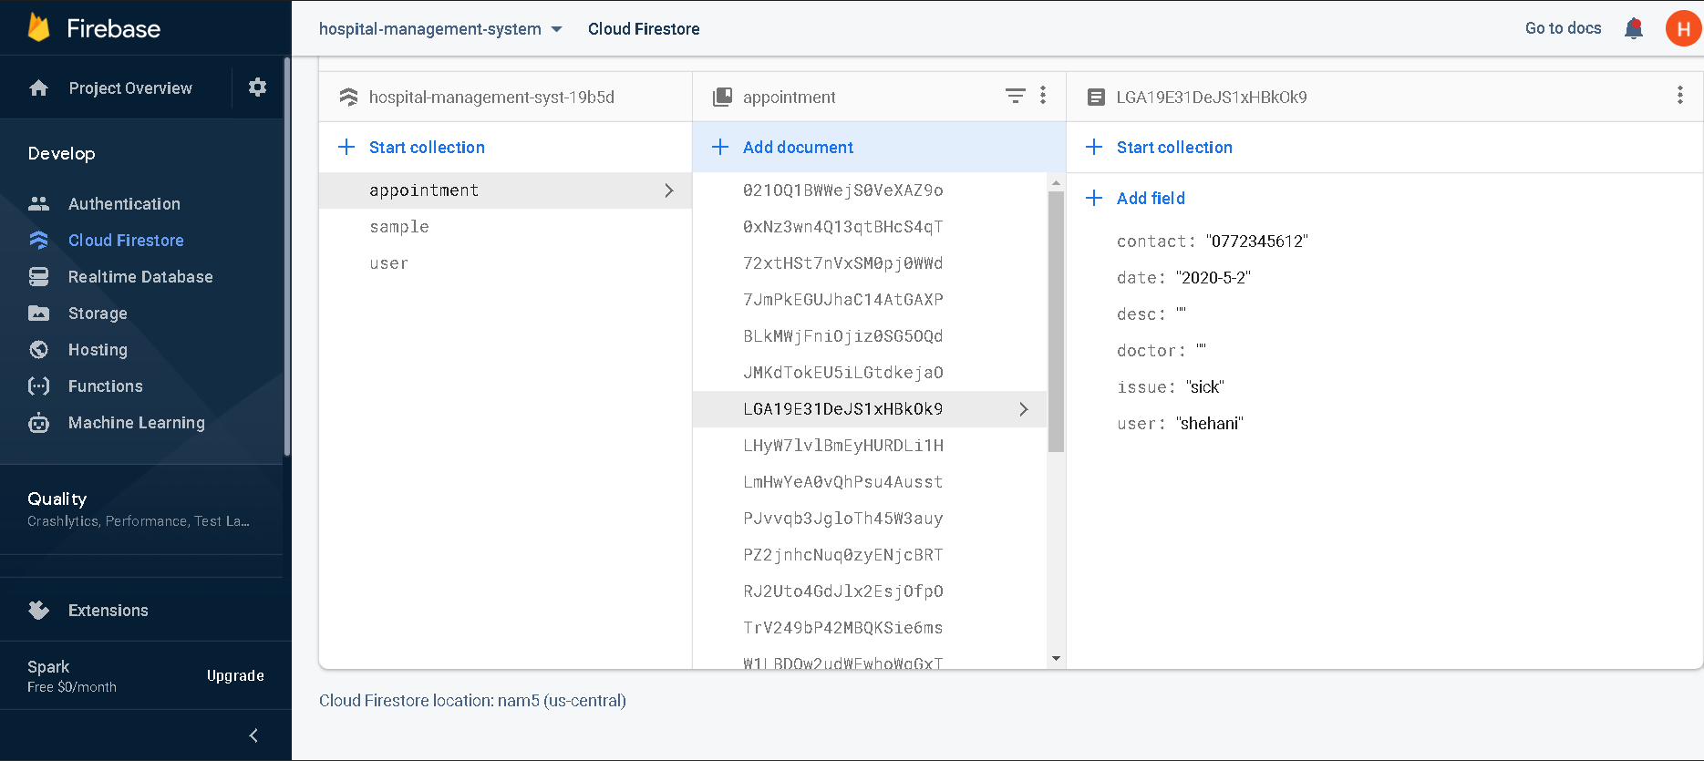

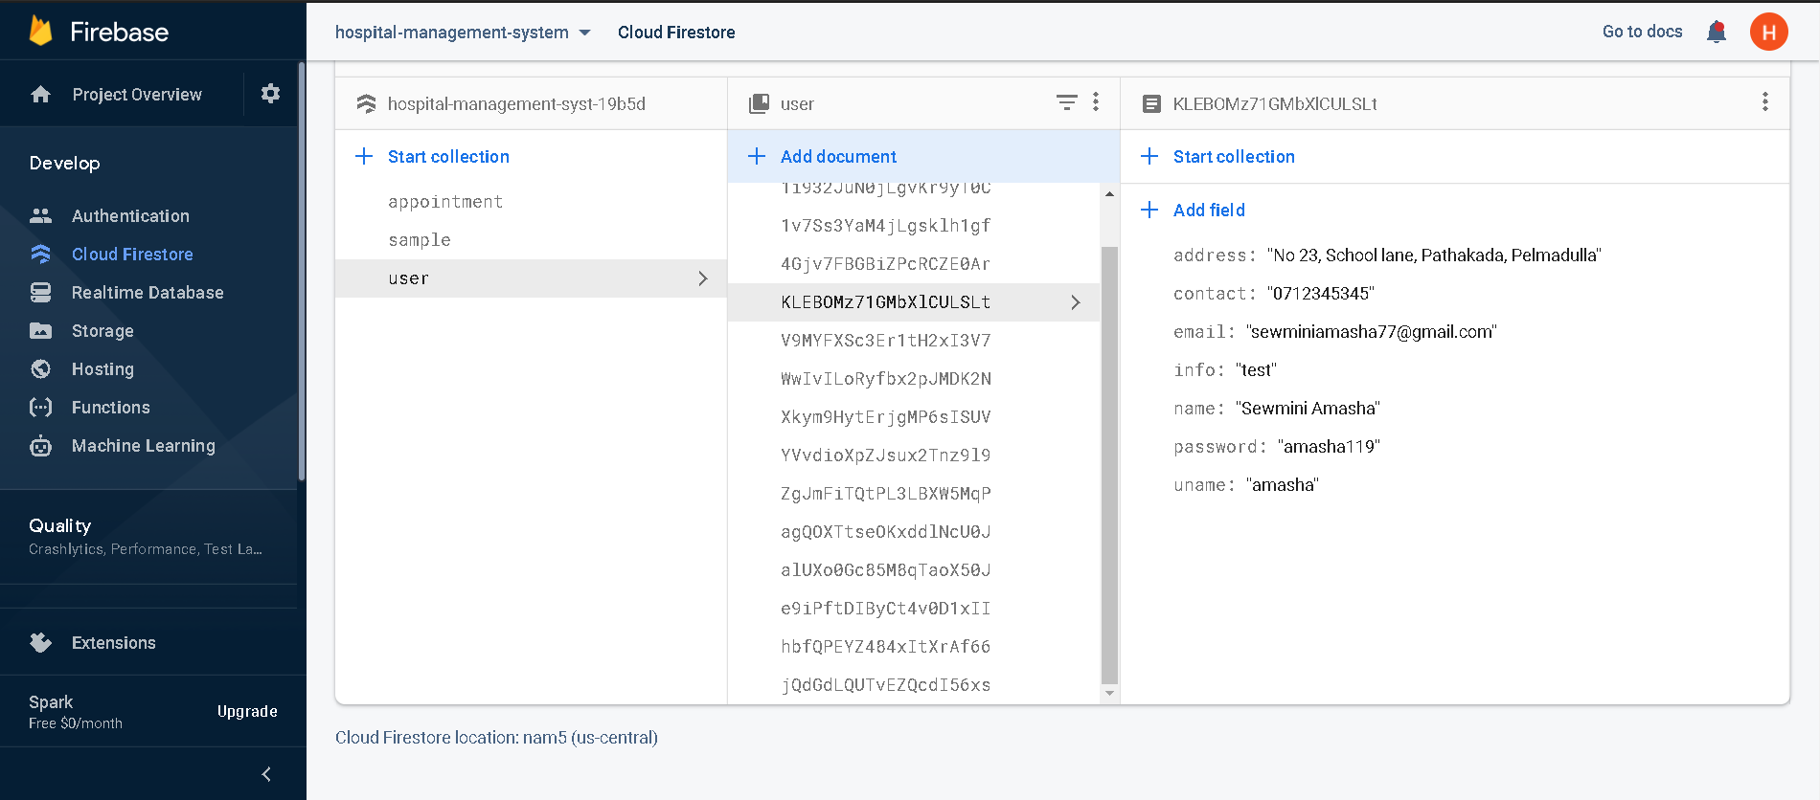

**7.Implementation**

**Testing**

Testing is the process of trying to discover every fault and weakness in the work product. It provides a way to check the functionality of components and deliver a quality product. Software system meets its requirements and user expectations and does not fail in an unacceptable manner.

**Types of tests conducted**

**Functional Testing**

Functional Testing is a Black Box testing technique, where the functionality of the application is tested to generate the desired output on providing a certain input or by clicking buttons or links. Briefly, Testing the behavior of the application as per the requirement has done.

**System Testing**

System testing is a level of testing that validates the complete and fully integrated software product. The purpose of a system test is to evaluate the end to-end system specifications. Usually, the software is only one element of a larger computer-based system. Ultimately, the software is interfaced with other software/hardware systems. System Testing is actually a series of different tests whose sole purpose is to exercise the full computer-based system the final step involves validations and testing which determines which the software functions as the user accepted here also some modifications were. in the completion of the project it is satisfied fully by the end user. Black Box testing technique, where the functionality of the application is tested to generate the desired output on providing a certain input or by clicking buttons or links.

**User acceptance testing**

User Acceptance Testing (UAT) is a type of testing performed by the end user or the client to verify/accept the software system before moving the software application to the production environment. UAT is done in the final phase of testing after functional, integration and system testing done.

So, followings are the User acceptance tests that I have done using each interface of the system separately.

**8.Contribution**

**Project Manager-W. A. M. Poornika (10025833)**

In this HMS project I played my role as the Project Manager. First we had a discussion with our team members that what we are going to do. We had a idea to do a Pharmacy management System but going through the discussions finally we selected Hospital management system to develop our web application. With assign of tasks we are enrolled our roles to do our tasks.

The main role I had was making things done.so I created a Trello board and add sprint backlogs to them. By adding cards to the sprints it was easy to have a clear idea about our tasks and project plans. This board have clearly defined that what we are going to do and what we have to do. Going through this board it was easy to keep all the team members on the track and had a idea about the next step. Always I put my effort to make sure springs are going as expect and keep update everything in this board.

I used agile principles to deliver this product with a high quality value. Always we had a better communication with our team members. We got weekly stand-up meetings to discuss problems, future plans, changes and processes. So it was more helpful to built our project successfully. And I motivated team members to complete the project on time with better quality. Always asked them to keep updated the tasks they are doing in the Trello and also encourage them to deliver the within the given period of time. We have to make some changes as first we decided to develop pharmacy management system we start the first phase of doing it. But later on we changed our plan to develop a hospital based management system Anyhow we adapt quickly to change the requirements and respond it. Going through these agile principles we were able to generate a high quality product to the user.

Next I completed the documentation part. Prepare the project proposal including background information, project description ,project scope, system architecture, project challenges ,maintenance etc. And prepared the cost estimation and time estimation. Finally with the implementation of the system I completed the Final report.

**Business Analyst - K.A.D.G.T. Wijepala (10026006)**

In this Hospital management creation project mainly I played a role as Business Analyst.

Firstly, I identified overall business requirements by searching several websites and observing. Then I created Introduction of overall Hospital system document.

I described

* Introduction
* Main functionalities.
* Introduction to clinic management system

Then I created HMS work flow according to HMS introduction.

Next I identified components of HMS and I created Component of HMS to clearly identify. I uploaded all documents to Trello dashboard and GitHub repository.

Then I clearly identify and noted Advantages of this HMS system.

Sprint wise we do all our parts together.

Then I created software requirements specification by clearly mentioned functional and non-functional requirements..

Finally I uploaded USE CASE diagram for Hospital management system.

**UI/UX Engineer – T.T. Kaluthanthiri (10025567)**

In this Hospital Management web application, my responsibilities are design interfaces, usability improvements and prepare design specifications. large majority of those visiting hospital website are experiencing an emergency, so users need find information very quickly. Because of this website is to be very easy to navigate quickly. I created a responsive design because the website should be accessible to mobile devices. First, I have communicated the project’s goals, objectives and vison with my team members. I have done my design in three stages. That is doing research, design, and user testing. In research phase I have study about existing hospital management systems, web applications, read articles and get some idea about how I plan the design. This help me to understand users’ characteristics, motivations, needs requirements. In design phase I define user personas for the product and get idea about how user interact with the product. After I draw some sketches and then got opinions from my team members. After I create wireframes and design using adobe XD. In user testing phase I created the prototype and test with my team members. I created a mock-up for team members to learn more about how visualize this website design.

I also contributed to project by coding some frontends pages and manage git hub repository. We use angular framework for frontend development. And we use git hub for version controlling. I created “Hospital Web Application” repository and gave access to other team members. I used visual studio code for development. and I help to handle Trello board by managing few cards.

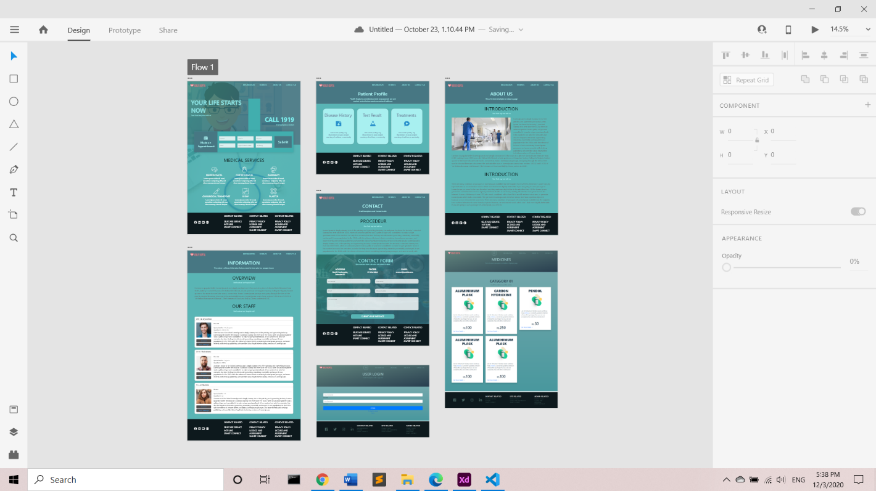Adobe XD dashboard

**Project Developer- Buddima Liyanagedara ( 10025487 )**

I am Buddima Liyanagedara a one of software developer in our hospital management project. We done several discussions about our project and firstly we select pharmacy management system as our software process management project. While we are doing that that project activities, we faced some functional issues. After some of team discussions we decided to do a Hospital management system.

As developers to develop that web application we used angular 10 as our development framework. Angular js is a front-end JavaScript framework. In primary stages AngularJS used JavaScript as its primary language. Then TypeScript has become the primary language of Angular. We also used HTML, CSS and Java Script for web application. We had to get lots of knowledge about Angular framework and type script programming language. If we had some idea about what is angular and how it works, we had not use angular to development any our past web applications. There for we need put lot effort for learn angular. For studying that I use w3Scools, tutorials point and solo learn like web sites and Codevolution (Angular Tutorial for Beginners), ChamiViews (Angular 8 Sinhala), ARC Tutorials (Angular 10 Tutorial for Beginners) like YouTube video tutorials.

I did the backend cording and designed the login, registration, user profile and home pages. And I also created the navigation and footer components. Visual Studio Code is the main code editor I used for that development. It was support me for development operations like debugging, task running, and version control. It is so useful to me in our development times. Google Firebase is a Google-backed application development software. After discussion with our team members whether the firebase is suitable for our backend, I used it for our backend development. Because it is real time and document wise database, it was so useful for our backend development. Agile software methodology is sprint wise methodology. we used it as our development methodology. It was so important when fixing bugs and to add some new functions. I also helped to do many activities related to our project.

While we are doing this project, we keep better communication among the team members. We discussed the problems that we faced, solutions for those problems, how to manage our time, what are thing we should include for our project, how we managed them and how we create this project successfully.

**Quality Assurance Engineer-H.D.S. Amasha (10025875)**

This Is the Hospital Management system test report that provides a summary of the results of the automation testing performed as outlined within this document. Most of these testing were done according to the users perspective. Also the admin of the system can also access the site pages that can access the site pages that can be access by the users. For our Hospital Management project we decided to test all the functionalities by the selenium IDE. Selenium is a very reliable testing software for test all the functionalities of the project.

So as the quality assurance engineer of this project, I have mainly focused on doing the user acceptance testing. I have to investigate product quality in order to make improvements to achieve better user satisfaction. As the QA engineer I have review requirements, specifications and technical design documents to provide meaningful feedback to the project team.

I have executed automated tests by creating scripts that run testing functions automatically, by using the selenium IDE. I have mainly tested the login functionality and the user registration of our system. Some validation tests are done to the login page and I have outlined those tests along with this document.



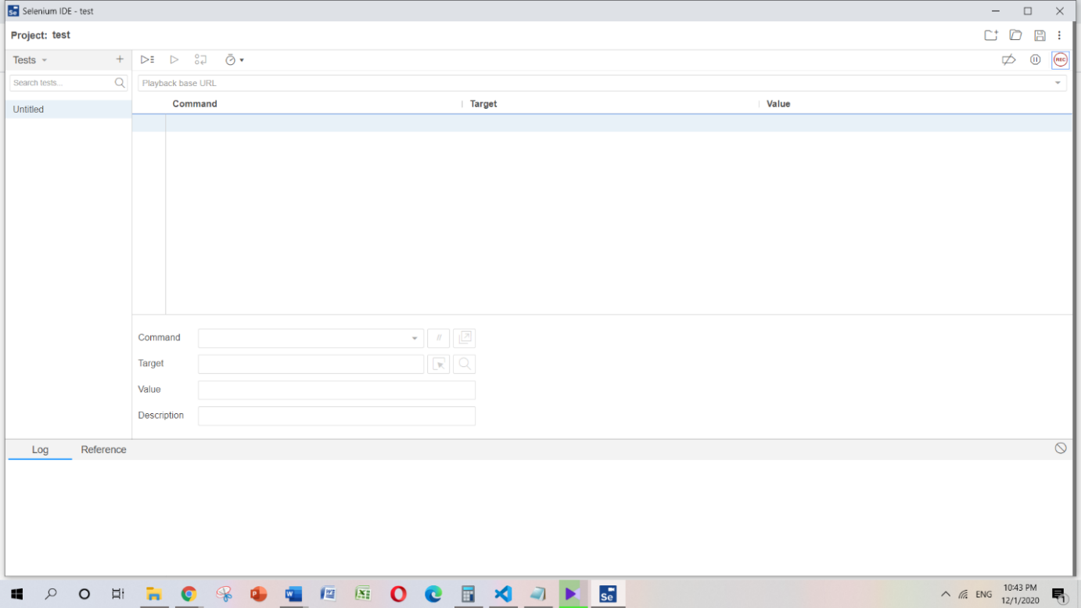

**User login test**

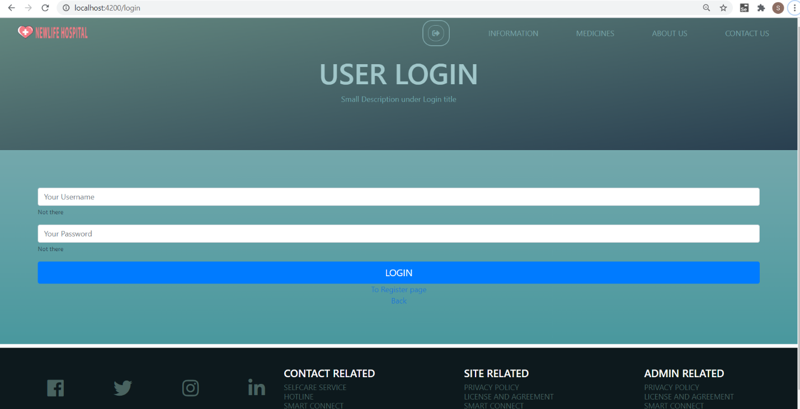

This is the user login page of our system. User can enter his or her user name to the text field given by clicking on it. The second text field is use to enter the user password. After entering the valid user name and a valid password and clicking on register button, user can successfully log in to the system.

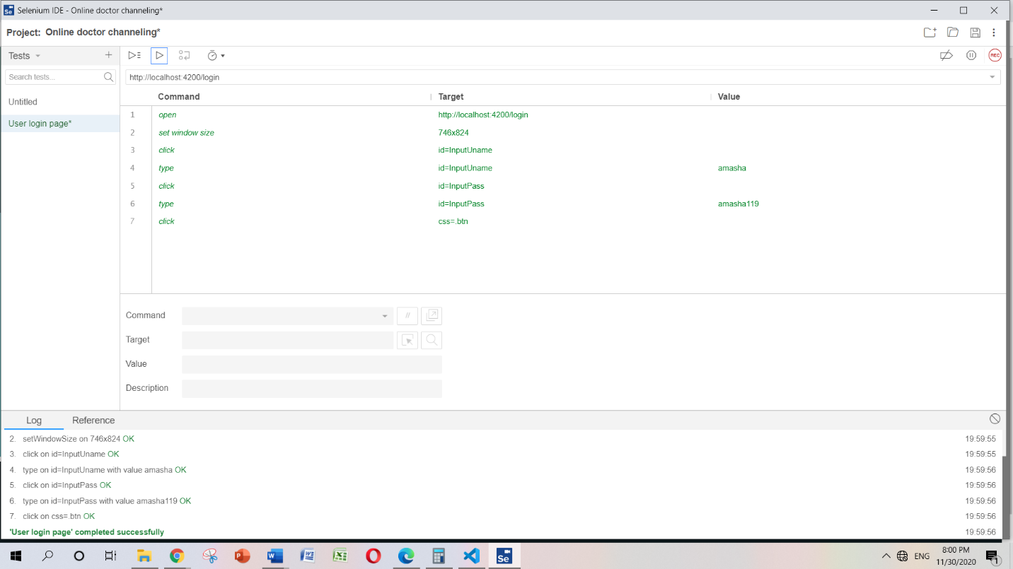

When the beginning of the testing, we have tested the user login section. User login has successfully tested without facing to any error successfully.

User name entered as – amasha

Password entered as - amasha119

After entering the user name and password user needs to click on login button. when the user successfully logged in to the system user can see his or her entered user name appeared in the top of the home page as follows,

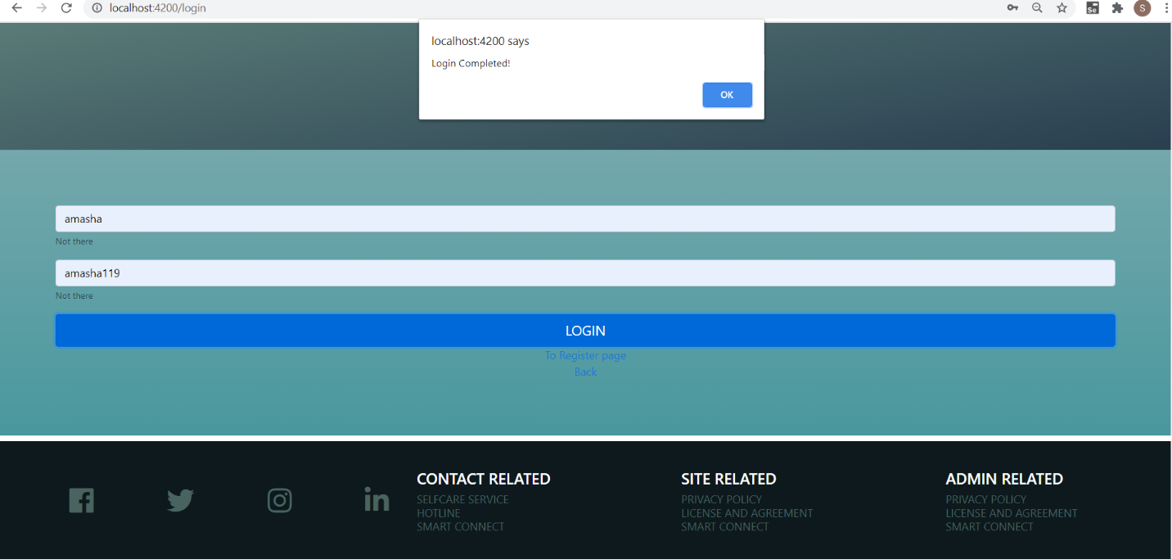

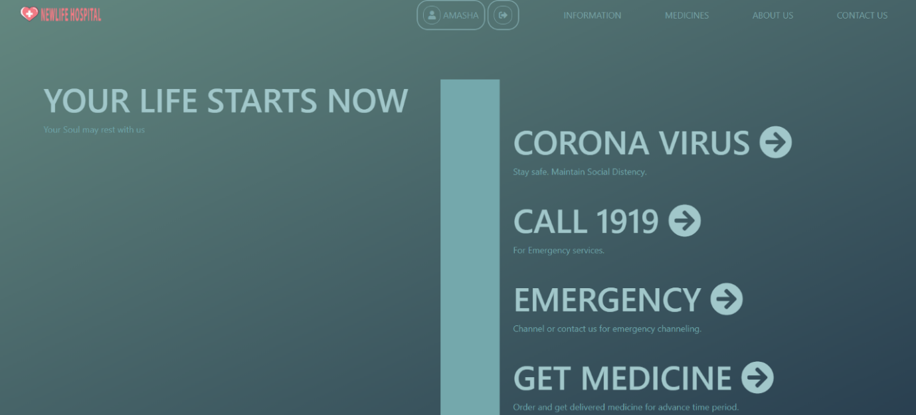

**User login validation test**

For the user login we have tested the all the validation on user login form.

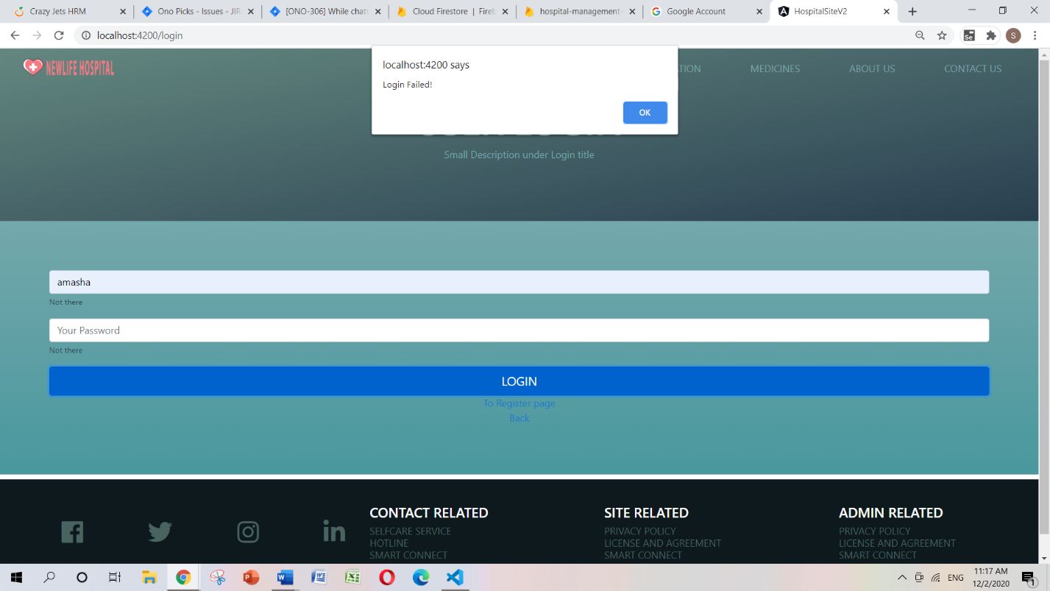

For the first validation I have tested click the login button without entering the user password. When the user tries to login without providing the valid password, a popup will display on the screen saying “Login failed” since providing the user password is mandatory to login to our system.

For the second validation I have tested the login by providing numbers and special characters to the password field.

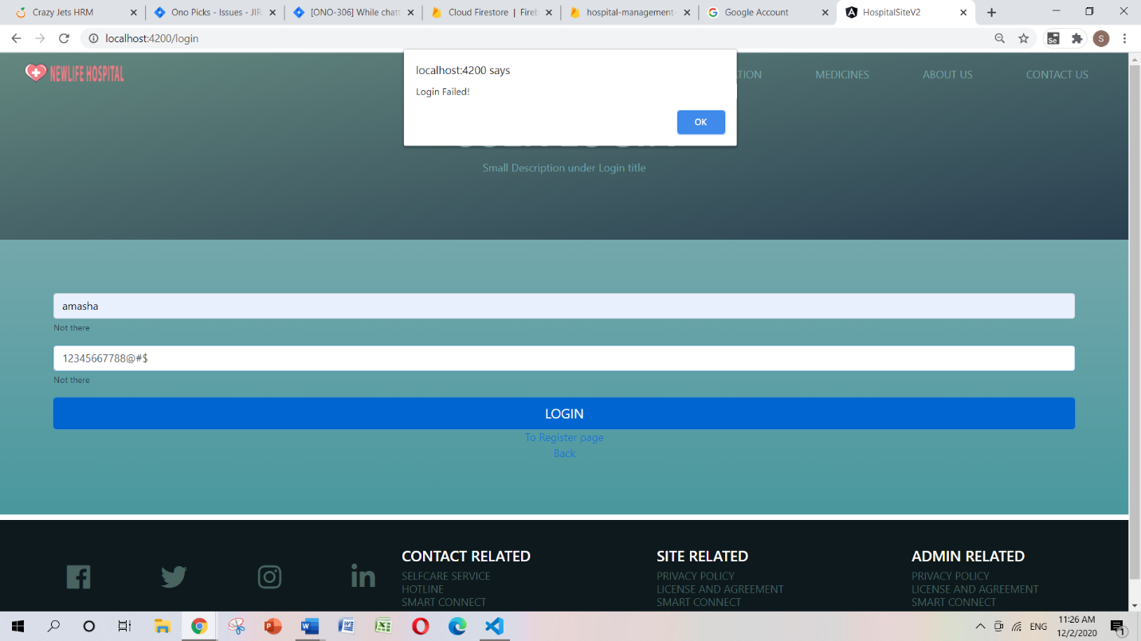

When the user tries to login by providing numbers and special characters a popup will display saying “Login failed” since it is mandatory to use letters (Lower case/Upper case).

**User registration test**

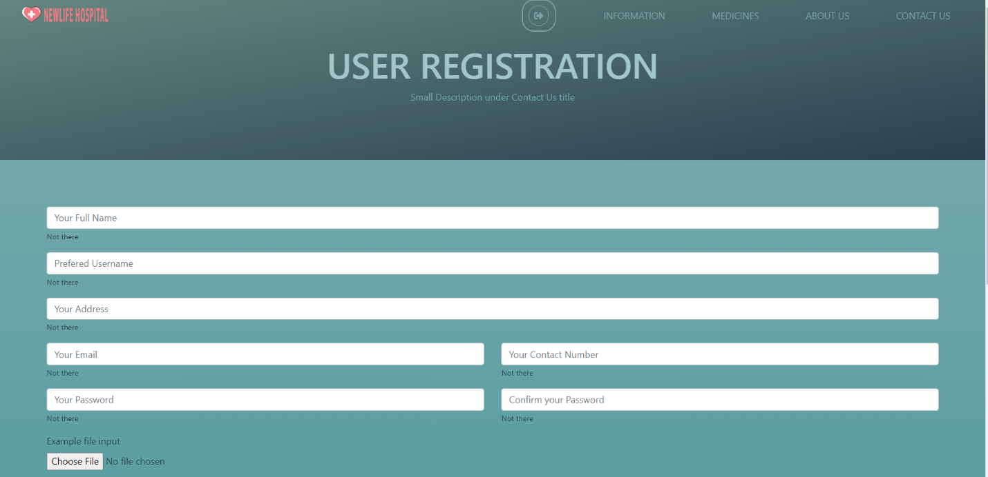

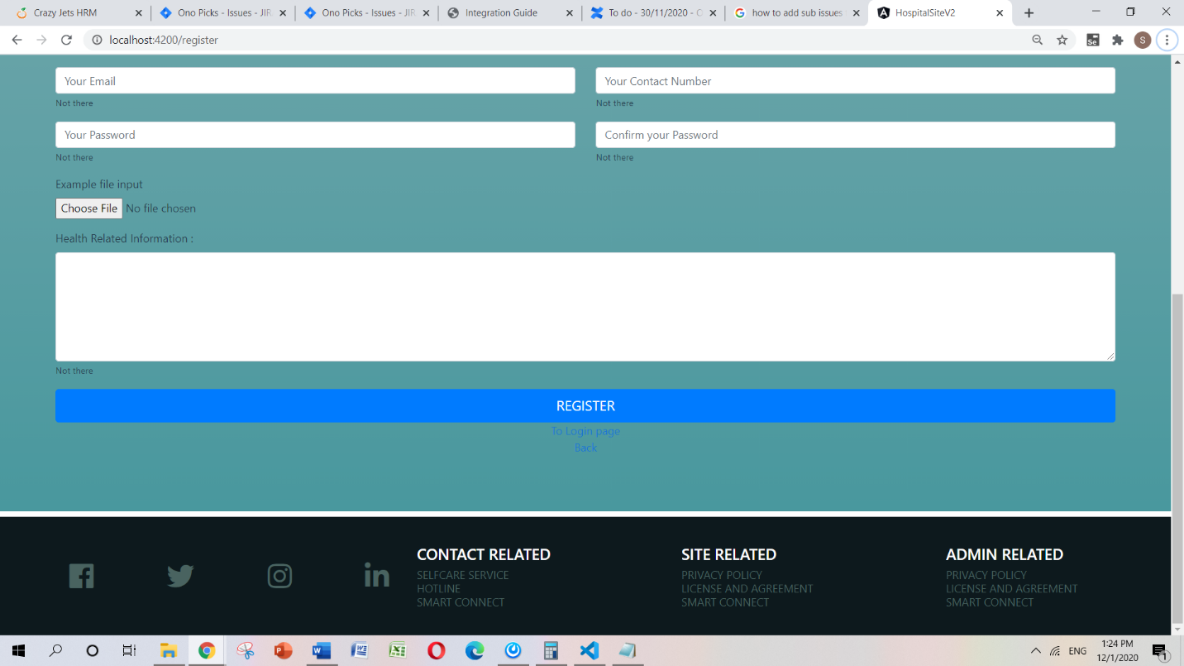

This is the user registration page of our Hospital Management system. User needs to enter full name, preferred name, Address, Email, Contact number, Password. User can enter any file regarding his or her past health related issue and also there is a special text field to enter health related information. After entering the all the details successfully user can be registered by clicking on the register button.

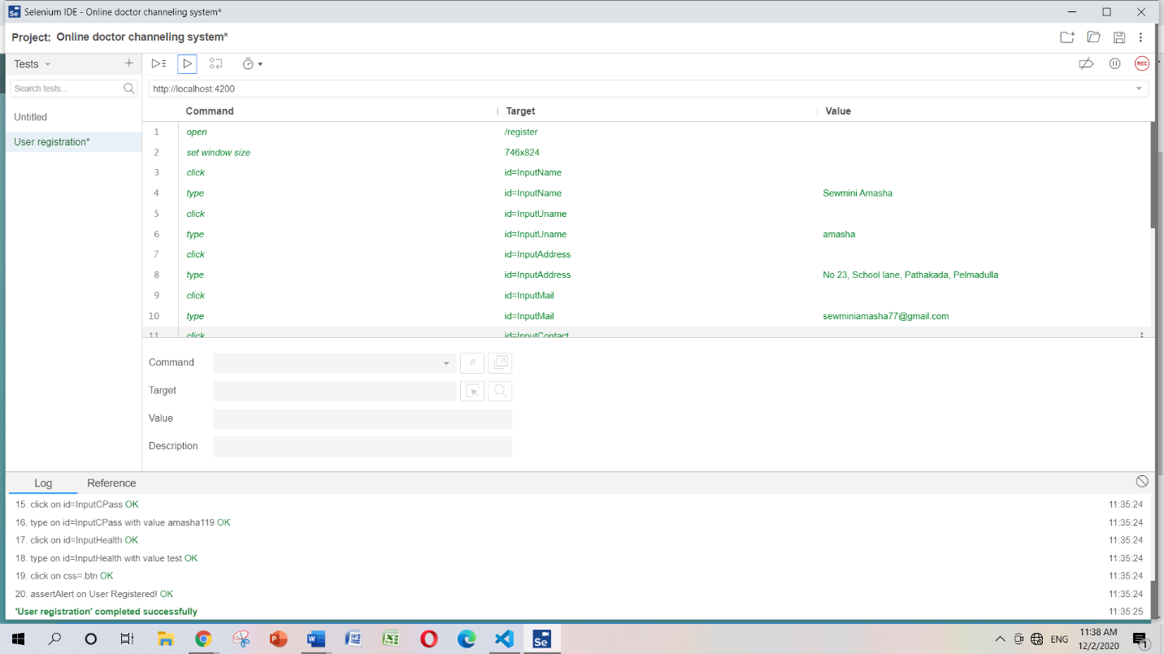

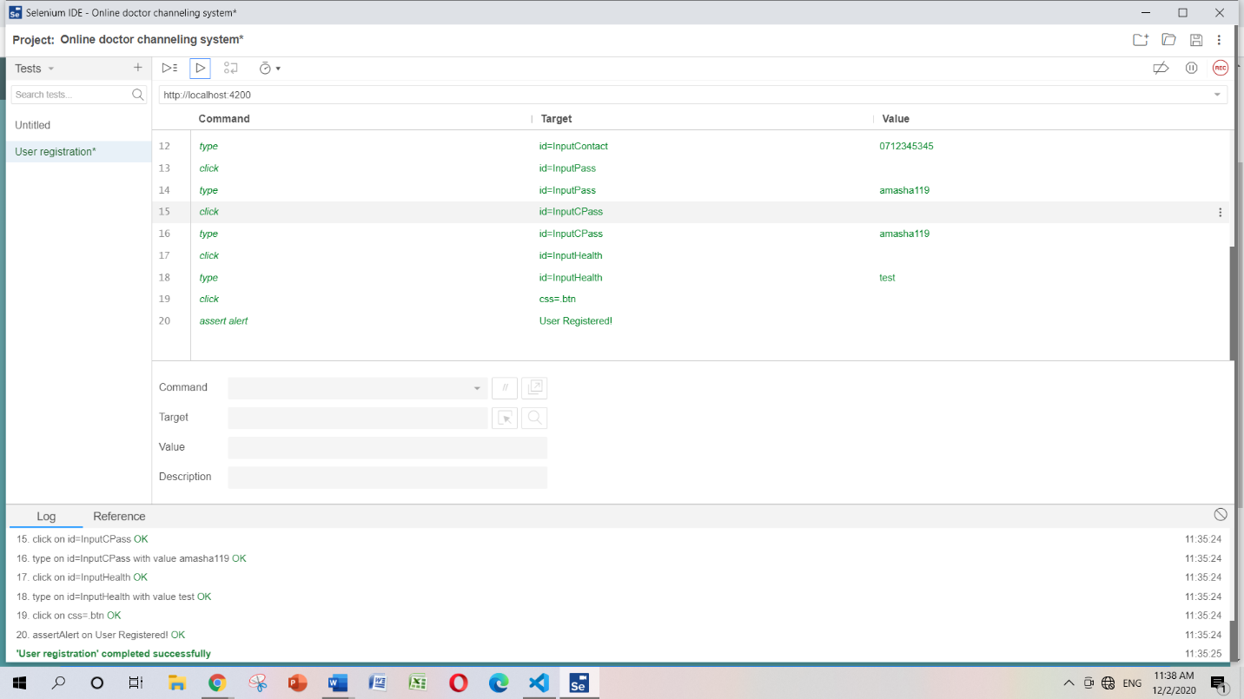

By providing the valid details to the registration form user can successfully registered to our system.

**Navigation bar test**

We have included four main menus to our navigation bar as follows, Information, Medicines, About us, Contact us.

**Information**

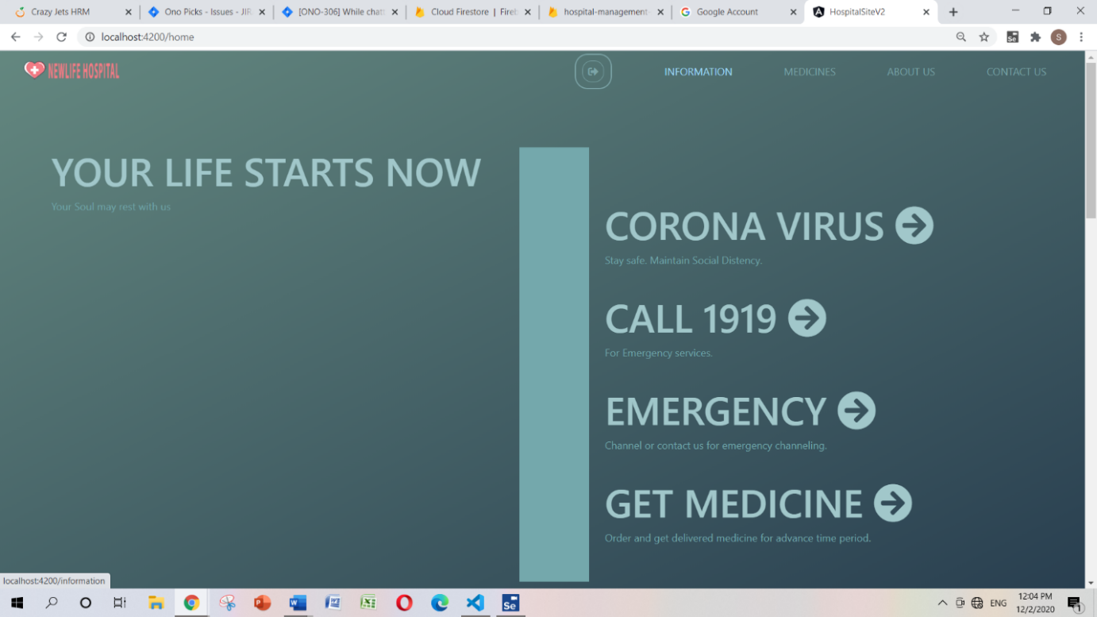

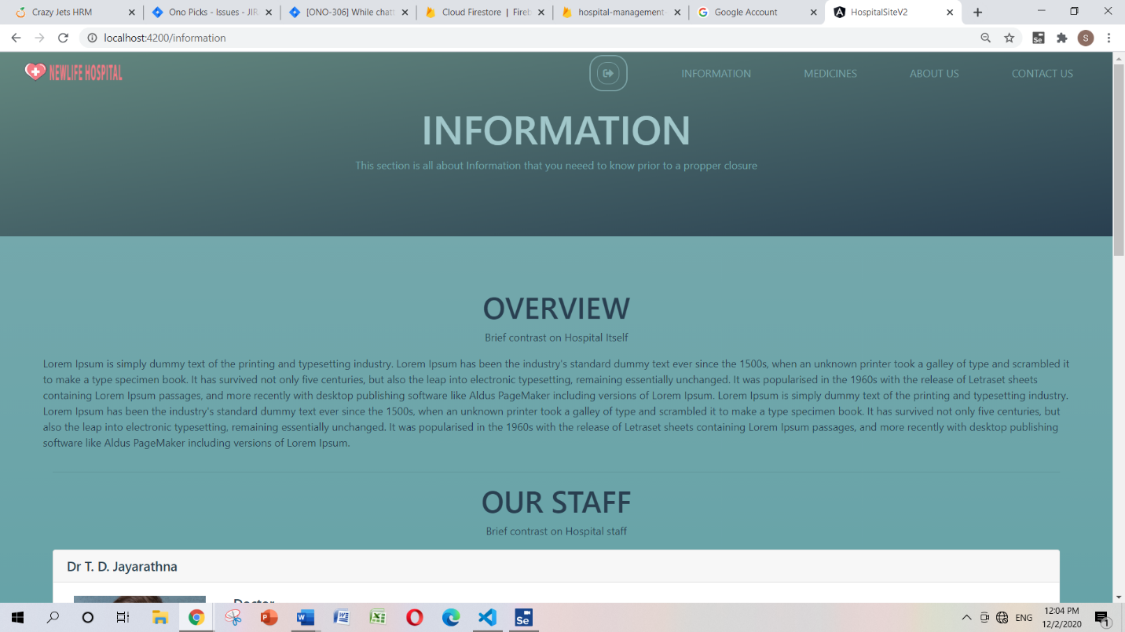

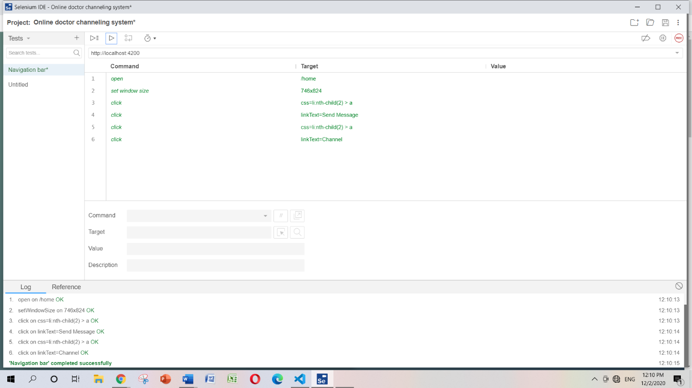

**Medicines**

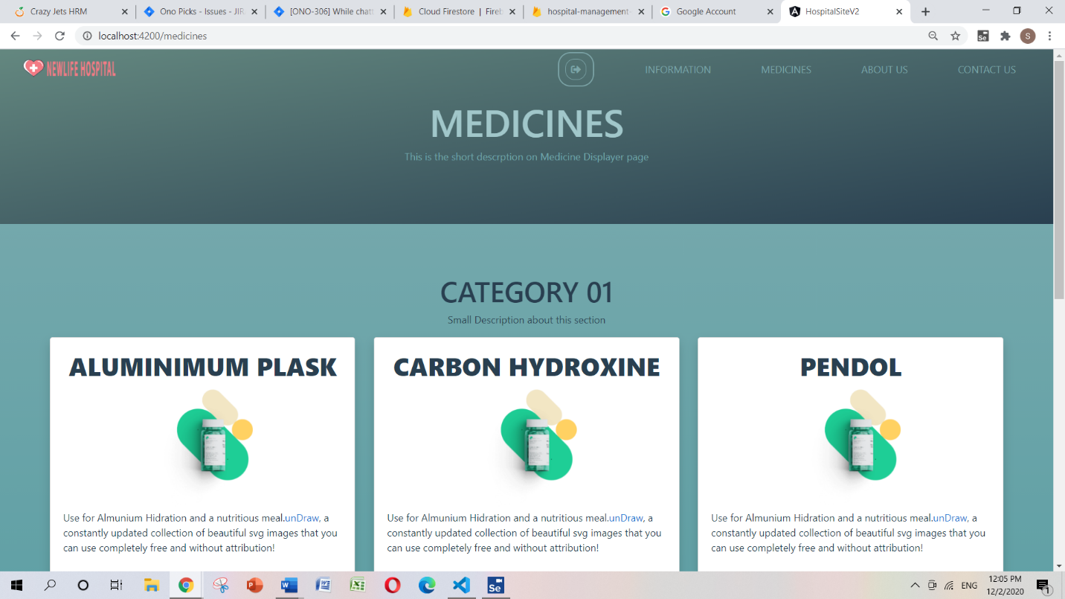

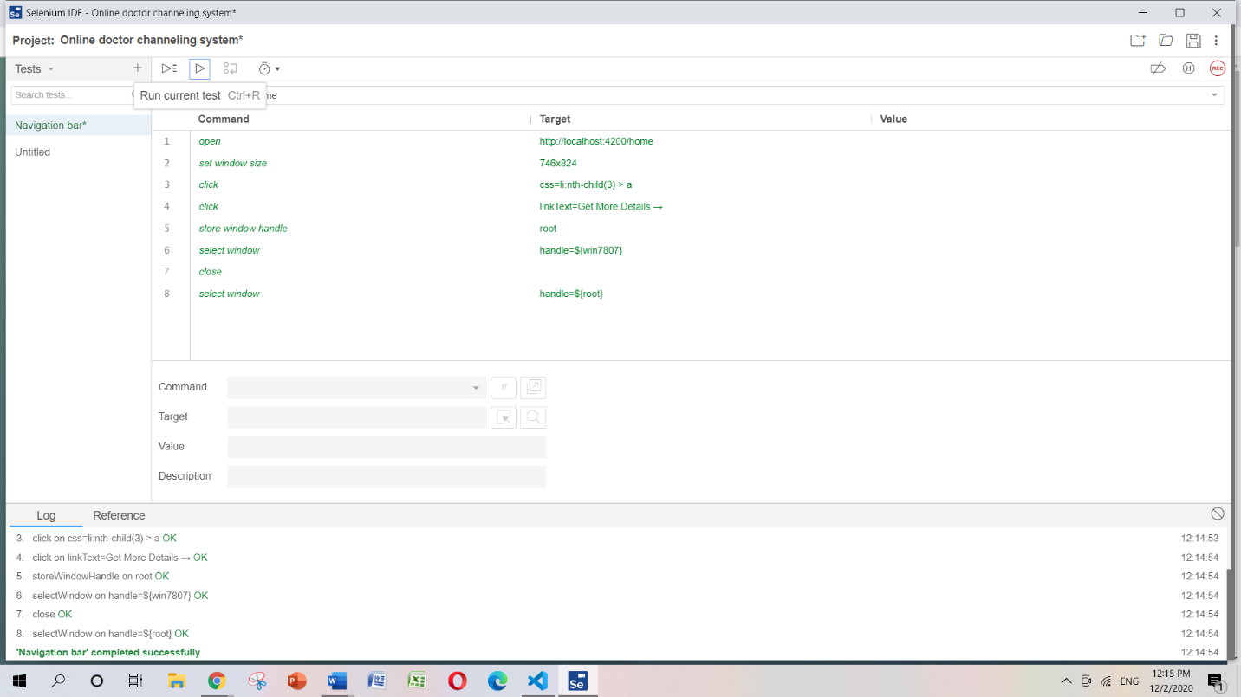

**About us**

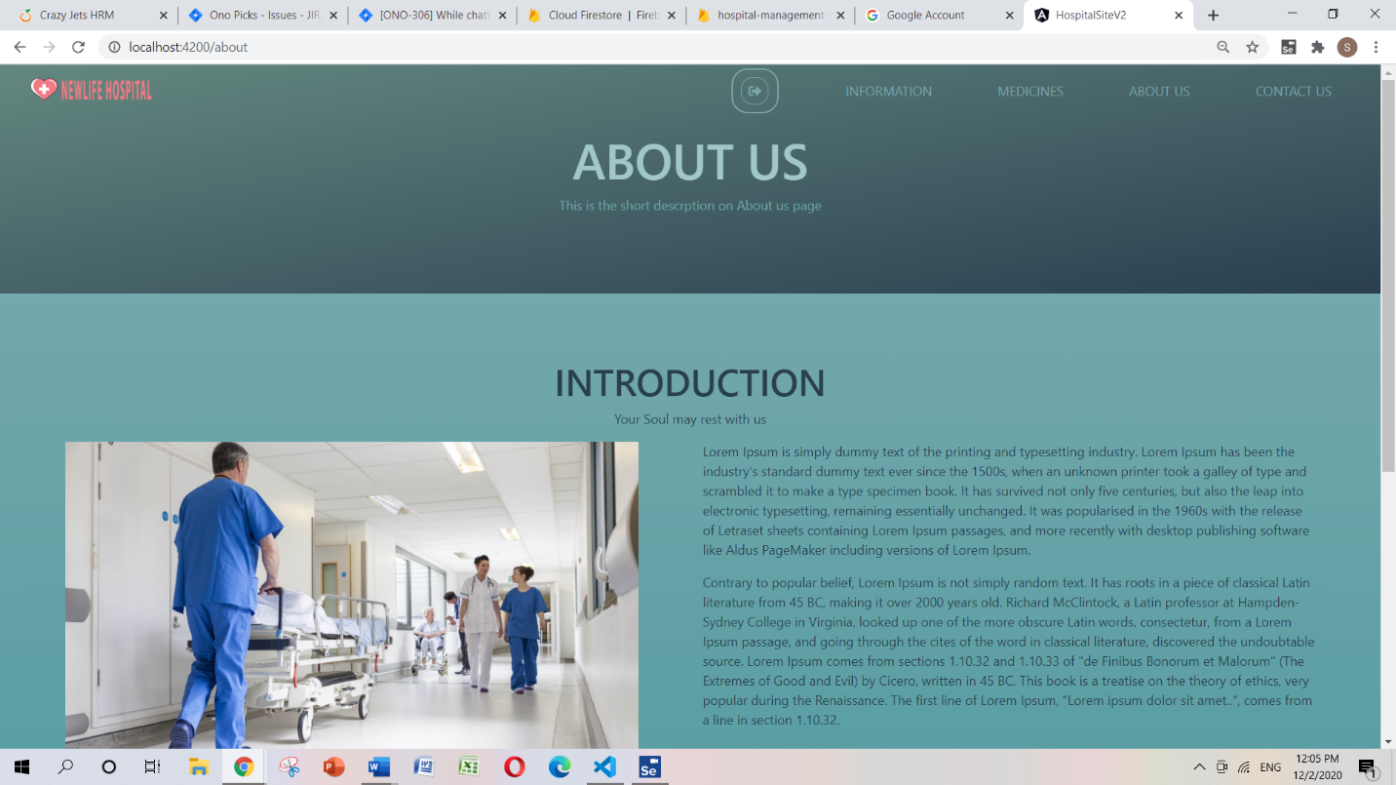

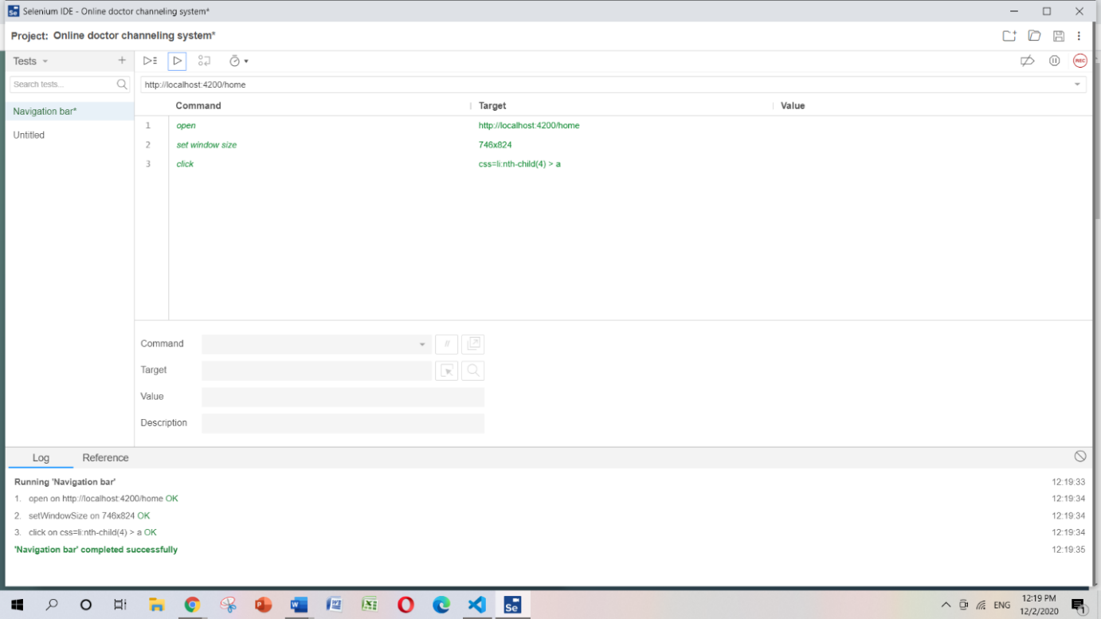

**Contact us**

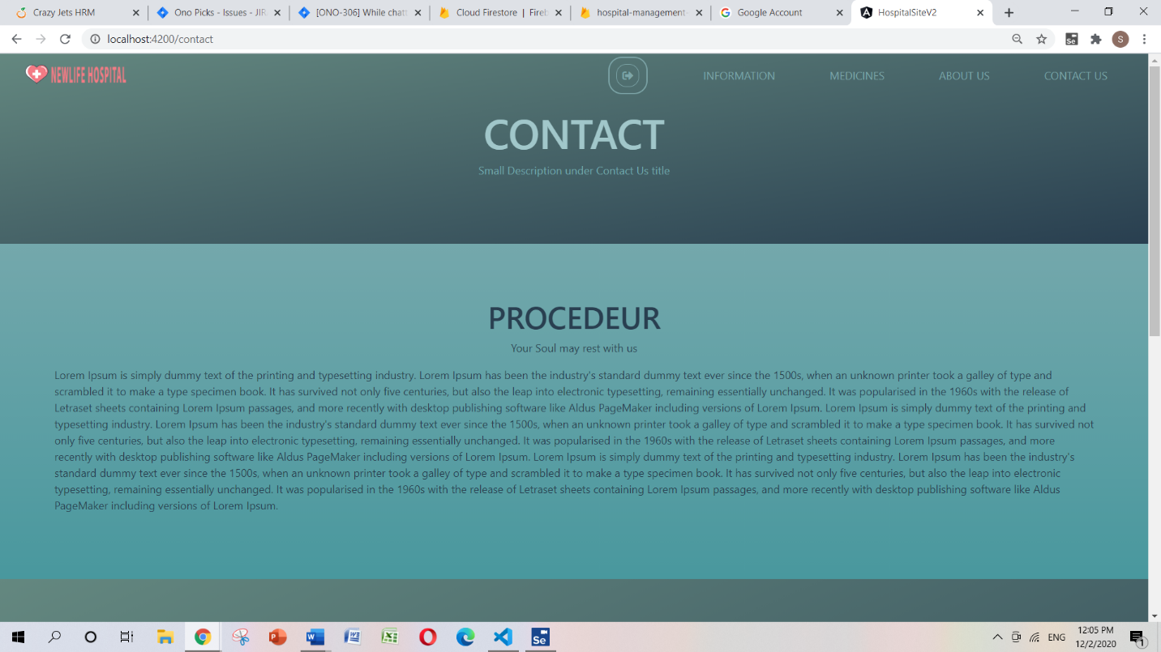

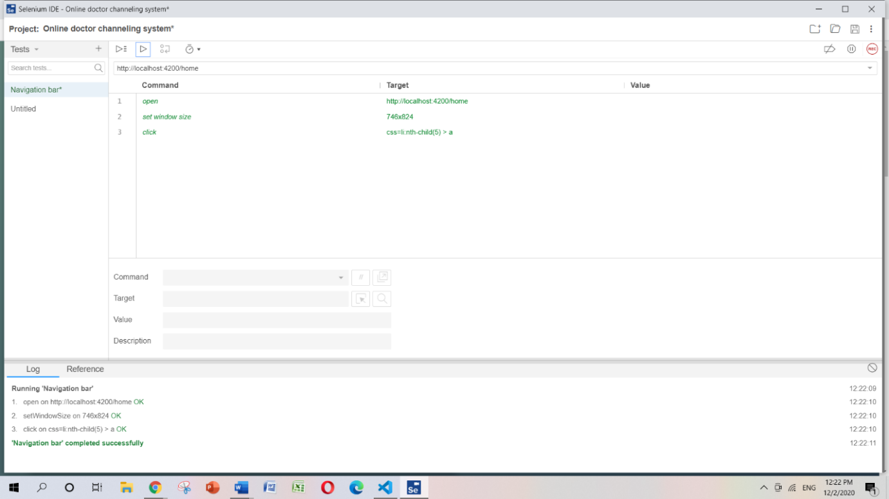

By clicking on the menus in the navigation bar, users can successfully navigates to the menus.

**Quality Assurance Engineer-K.W.M.S.Rashmika** **(10026017)**

For our Hospital Management System project, we decided to test all the functionalities by the selenium IDE. selenium is a very reliable testing software for test all the functionalities of the project. we have tested the User Appointment, Contact Form, Our Services part successfully tested without any errors.

**User Appointment UI Design**

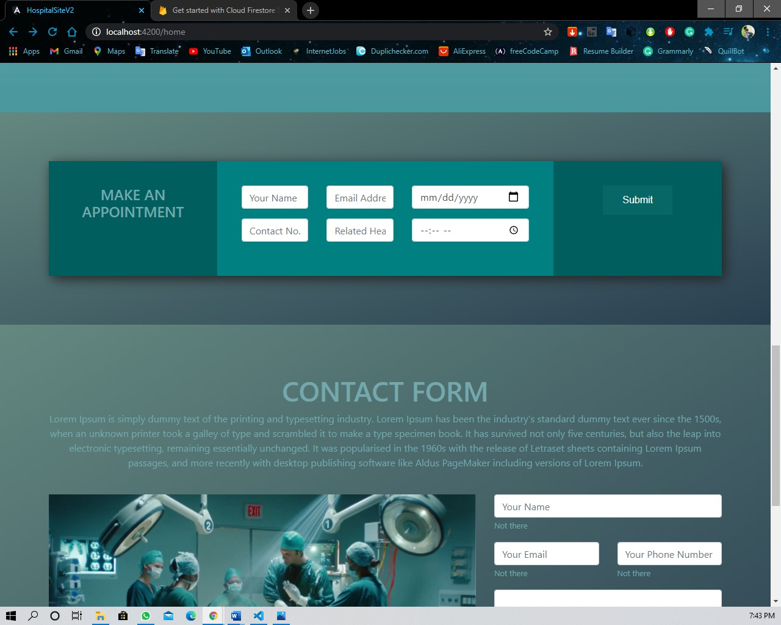

This interface displays of the user appointment. We can choose appointment what we need to check. When we choose date, time, then screen will display the details of relevant related health. We can select the health by click the submit of related health.

**User Appointment Test**

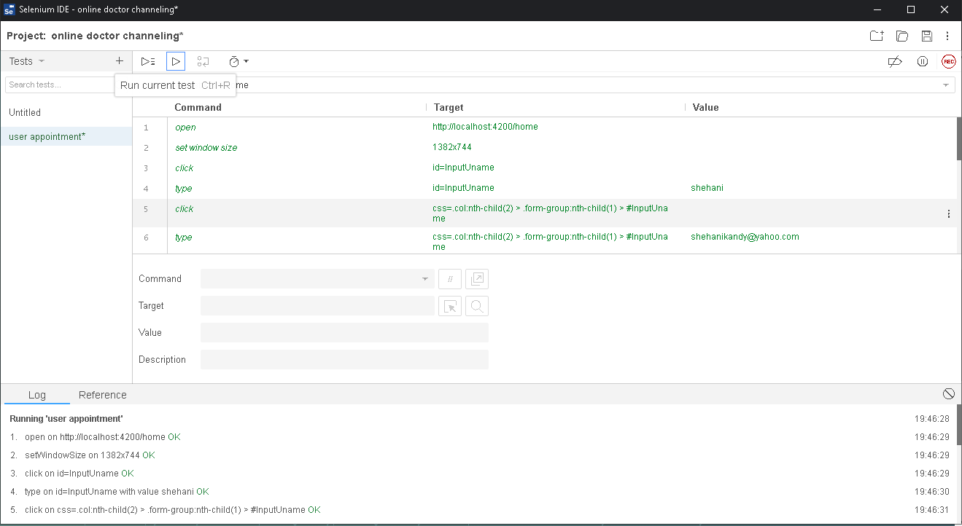

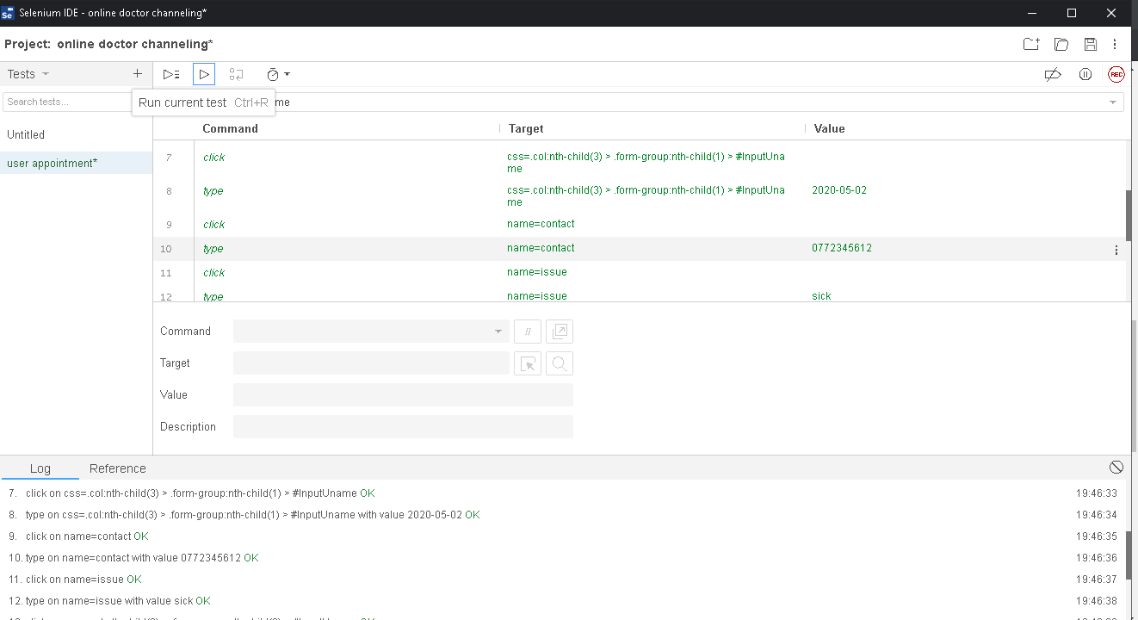

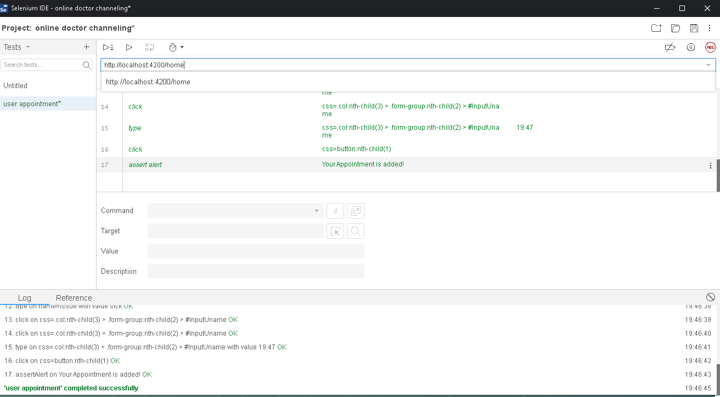

When the beginning of the testing, we have tested the user appointment part. User appointment has successfully tested without any error

**Contact Form UI Design**

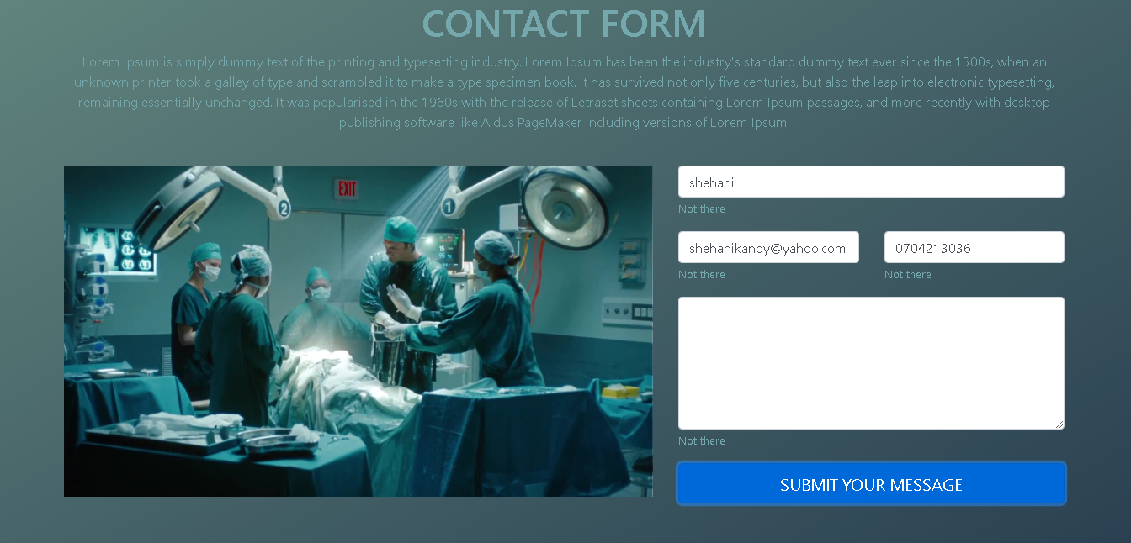

Anytime user can get details /

**Contact Form Test**

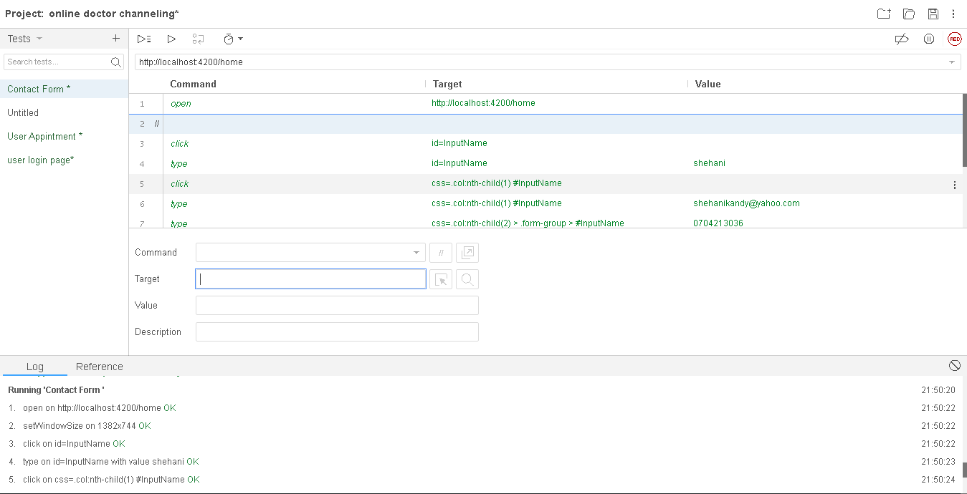

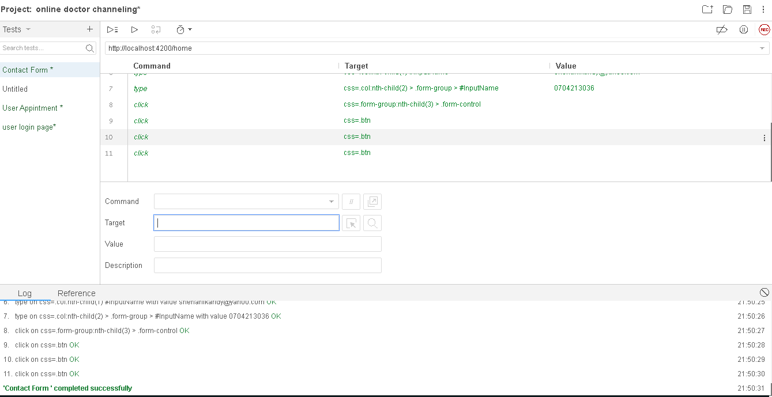

When the beginning of the testing, we have test the Contact Form part. Contact Form has successfully tested without any error.

**Our Services UI**

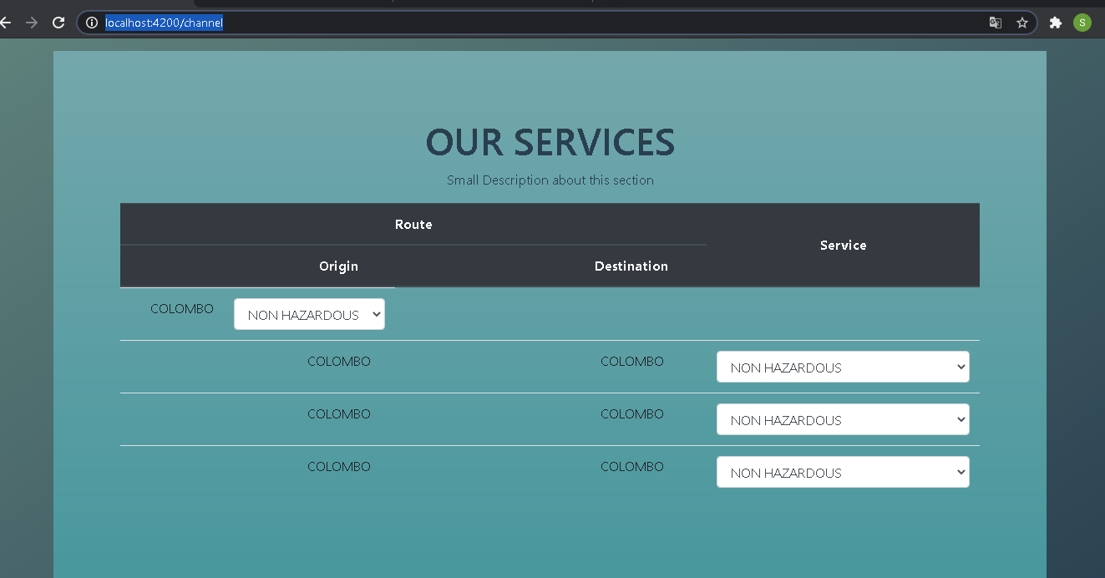

**Our Services Test**

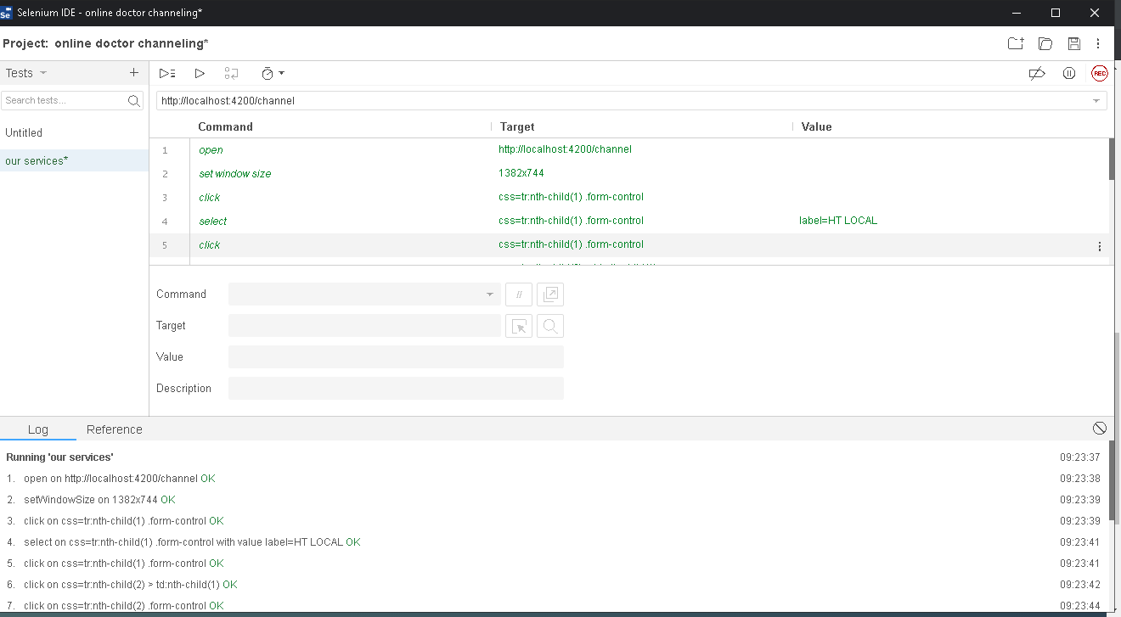

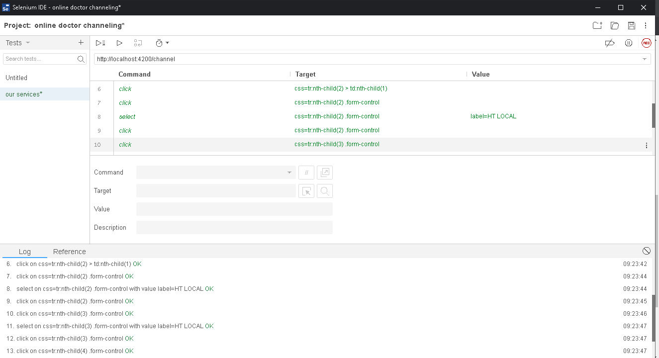

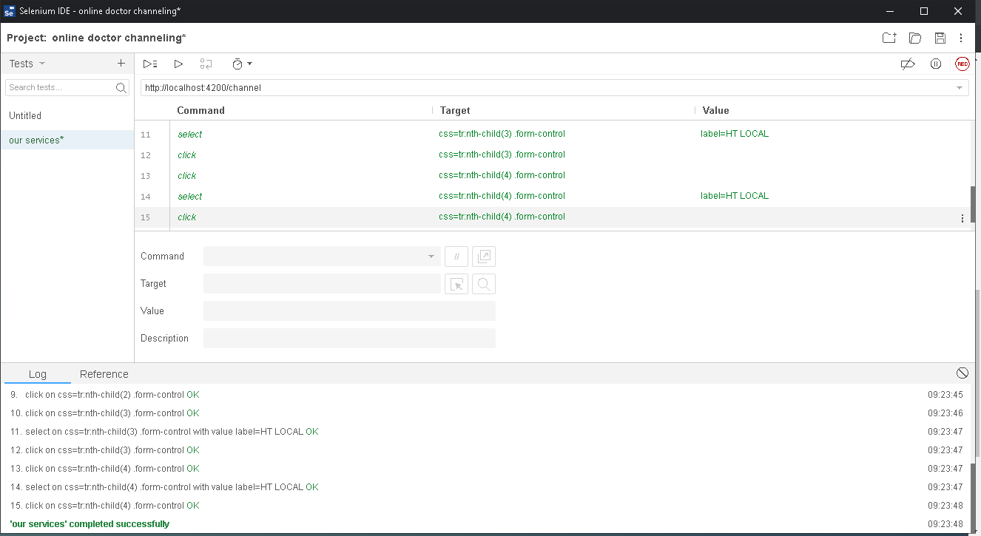

**9.Conclusion**

The Project Hospital Management System is for computerizing the works in a hospital. This system is more helpful and accurate rather than a manual system and mostly it is error free. This software system take care of all the requirements to a average level and it is so easy and simple to use for the staff as well patients. Updating of Information is very easier. System security, data security and reliability striking features in this system.

This system will generate test reports, channelling services and treatments etc. Any person can make appointment to meet a doctor through this system. And also provide the stock details of medicine in the pharmacy etc. And the System will provide the facility of backup as per the requirement.

**10. Future Enhancement**

We can enhance this this by including more facilities such as adding a billing system, introduce this system worldwide.

**11. References**

GitHub link - <https://github.com/TTkaluthanthiri/Hospital-Web-Application.git>

Trello link- <https://trello.com/b/9vvfut08/web-application>

Angular Setup- <https://www.codingforentrepreneurs.com/blog/angular-setup-guide>

Tutorials- <https://www.tutorialspoint.com/asp.net>

**Team Members**

UI/UX Designer-T.T. Kaluthanthiri – 10025567

Developer- L.B. Vijayabandara- 10025487

QA Engineer- K. W. M. S. Rashmika 10026017

QA Engineer- H.D.S.Amasha-10025875

BA-K.A.D.G.T.Wijepala-10026006

PM-W.A.M.Poornika-10025833

*****************************THE END**************************